**USER**

**GUIDE**



**Author: Quang Nguyen**

**Date: 28/05/2017**

**Revision history**

|  |  |  |  |
| --- | --- | --- | --- |
| **Version** | **Date** | **Author** | **Notes** |
| **1.0** | 28/05/2017 | Quang Nguyen | Created |
|  |  |  |  |
|  |  |  |  |

Contents

I. INTRODUCTION 4

1. Purpose 4

2. Scope 4

3. References 4

4. Definition, Acronyms and Abbreviations 4

II. PROJECT OVERVIEW 4

1. Project goals and objectivities 4

2. Scope definition 4

3. Constraints 4

4. Project process 4

III. PROJECT RESOURCES 4

1. Human resource 4

2. Non-Human resource 4

IV. PROJECT SCHEDULE 4

# INTRODUCTION

## Purpose

-This document describes decision of chosing agile method over traditional one.

-Evaluate Process chosen with Homeground analysis.

## Function of user guide

* User Guide is a document designed to help users and potential of Swappal. Include:
  + Swappal:
    - Guide to the whole system of Swappal
    - Guide to use functions of Swappal
  + Swappal CMS:
    - Guide for customer and development team can manage Swappal

# SWAPPAL

## Function of Swappal

* Login to Swappal
  + Login with Swappal account
  + Login with Facebook account
* Register account
* Logout
* Create profile
* Edit profile
  + Edit profile information
  + Change profile picture
* View Profile
  + Skill
  + About user
  + Review
  + Profile picture
* Search skill
* View news
* Swappal Foundation
  + Contact
  + FAQs
  + About Swappal
* Send request swap
* Exchange swap
* Review
  + Skill rating
  + Service rating
* View exchange swap log

## Guide to function

* 1. **Register to Swappal**

At the beginning, we are in interface homepage 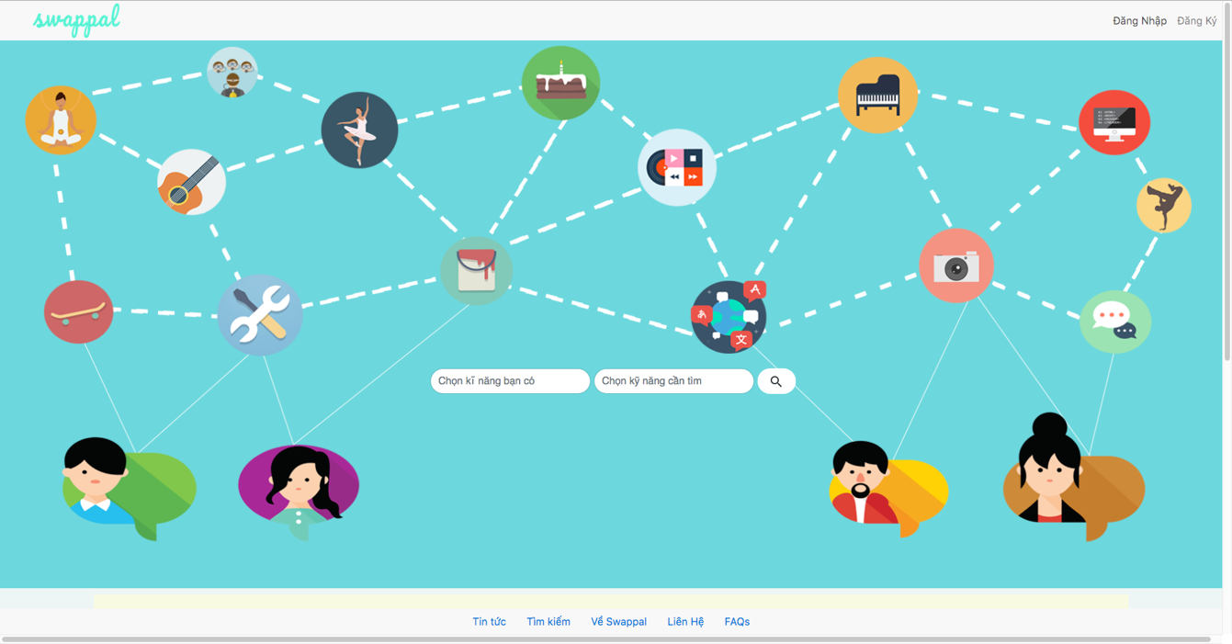

Click on “Đăng ký” button, sysem will display the screen below, user fill in email , password and confirm password fields

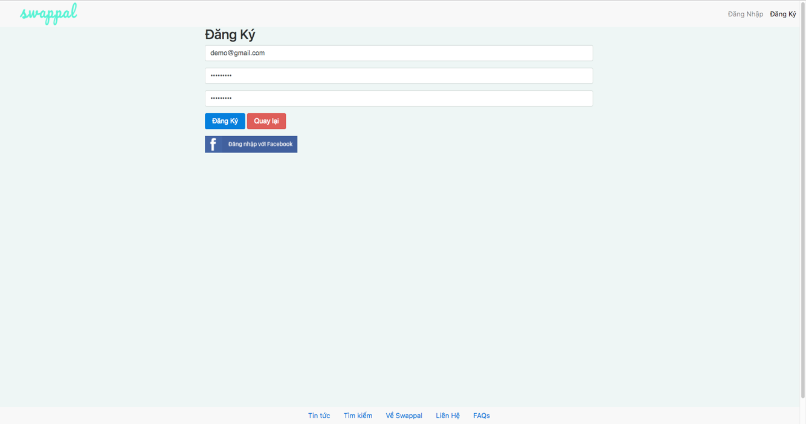

After register success, system turn back to homepage

* 1. **Login to Swappal (Swappal account)**

After register success, user click on “Đăng nhập” button to login to Swappal

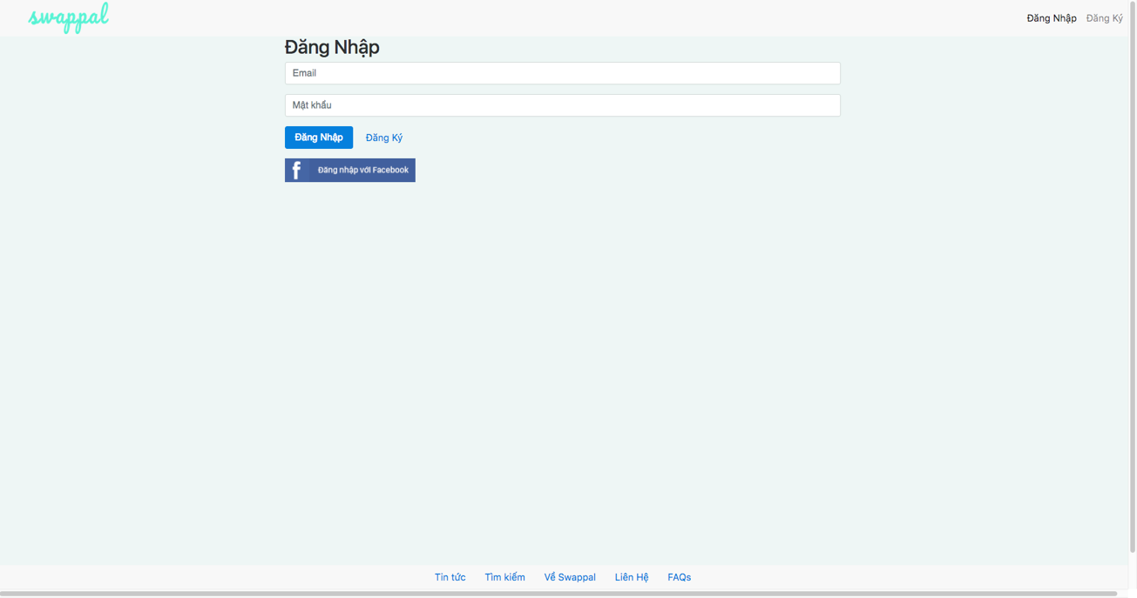

User fill in email and password fields, system validate email and password to access user to Swappal

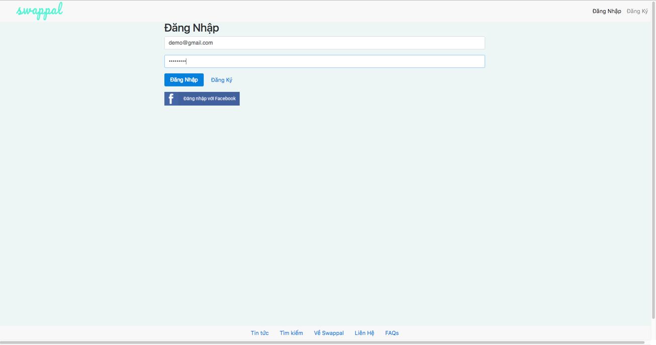

If that is the new account, Swappal will display “Chào mừng bạn đến với Swappal” to welcome the user to Swappal and create profile.

* 1. **Create Profile**

User fill in required fieds (“Bạn tên gì?” , “DOB”,”Giới tính”) to create profile

Note: User have to greater than 16 years old to user Swappal

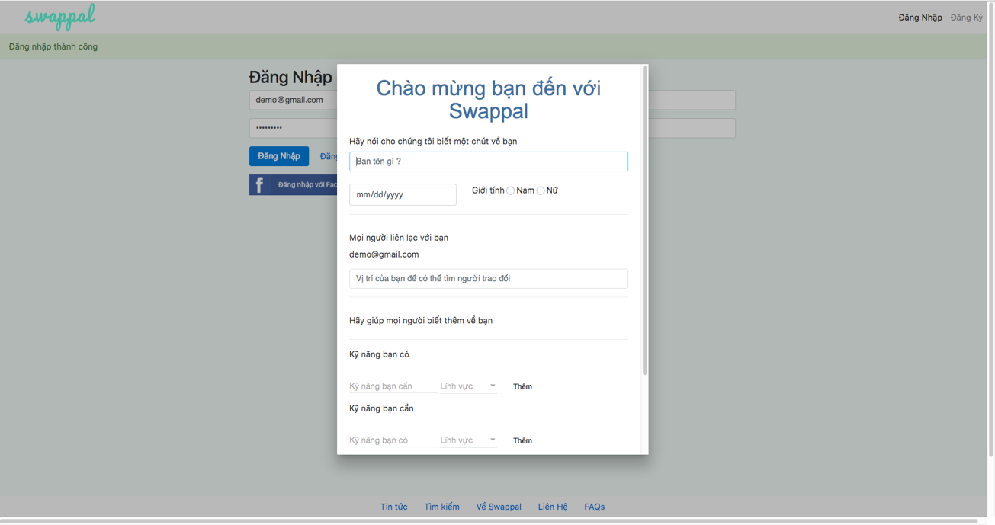

Choose skill category at “Lĩnh vực” to display skill of user have and need to swap, click “Thêm” button to add skill to profile (user can add many skills)

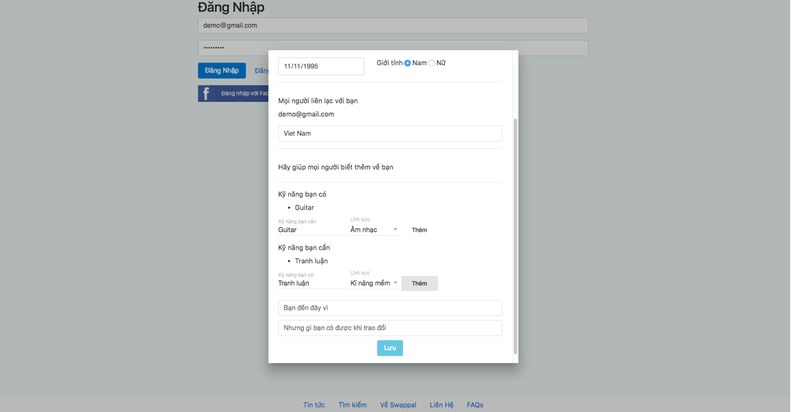

Click on “Lưu” to save profile information and Swappal will return to homepage with name of user just created

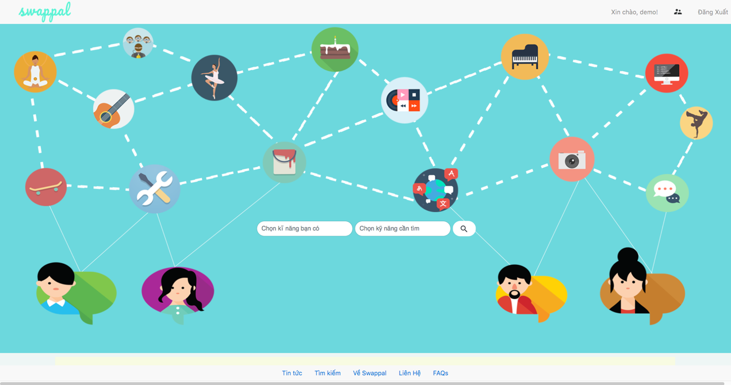

* 1. **View profile**

User click on name on the top right to go to profile page include 3 tabs (Kỹ năng, Về tôi, Đánh Giá)

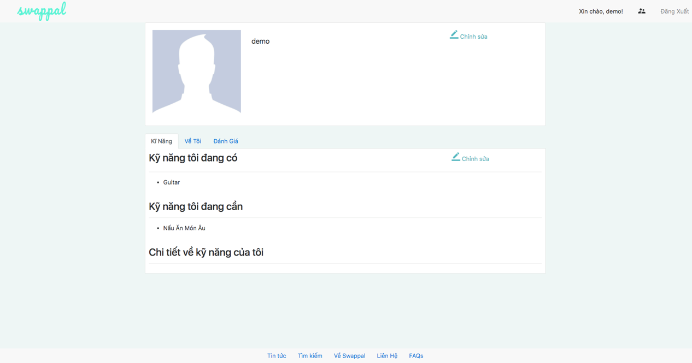

In “Về tôi” tab include contact information, achievement, basic information, mission of user, reason why user came here

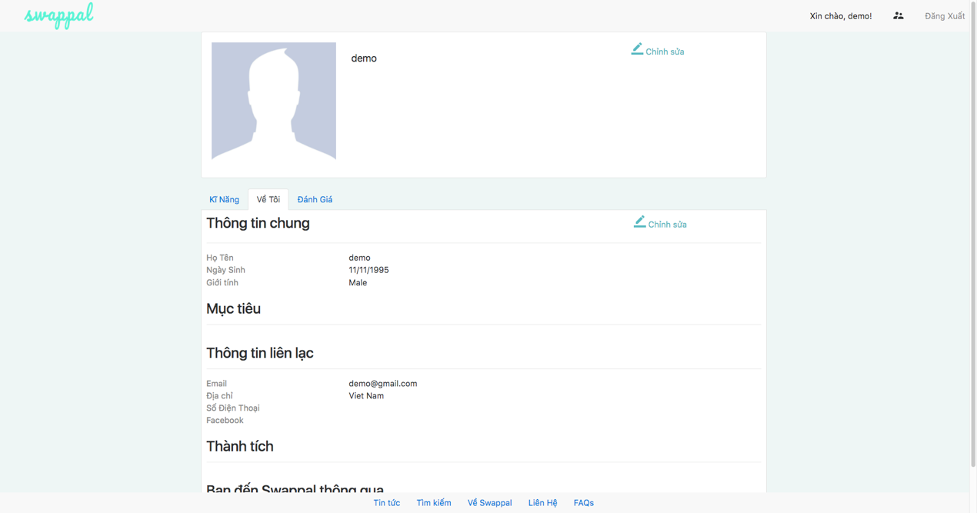

In “Đánh Giá” tab, other can view review list of this user to consider swap with

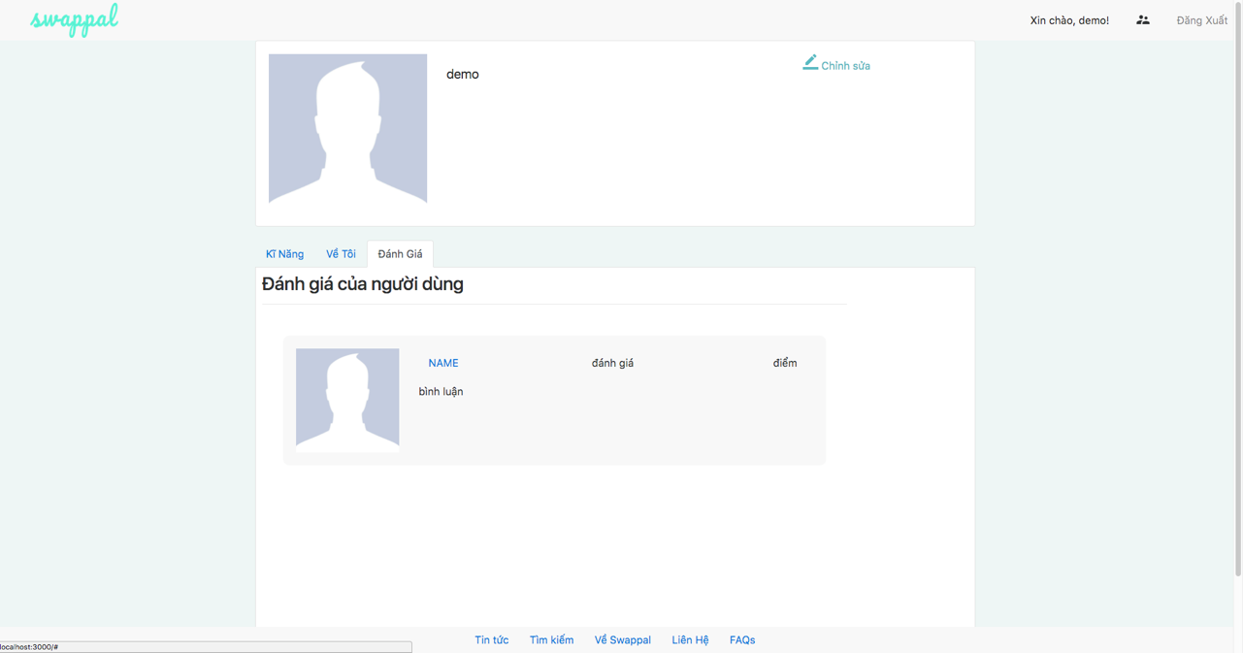

* 1. **Edit profile**

In profile page, user can edit profile if have any change

User can add more skill in “Kỹ năng” tab

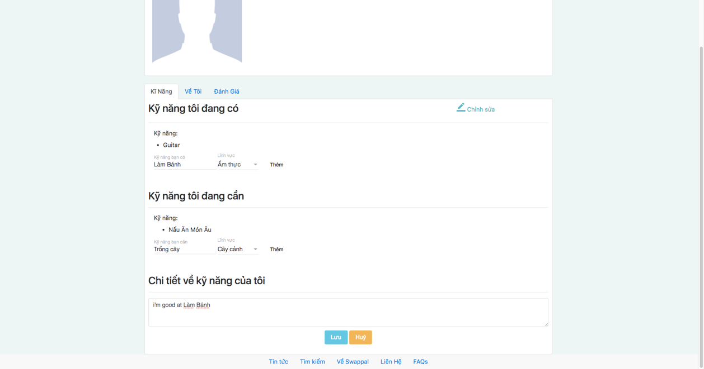

User can add or edit information in “Về tôi” tab

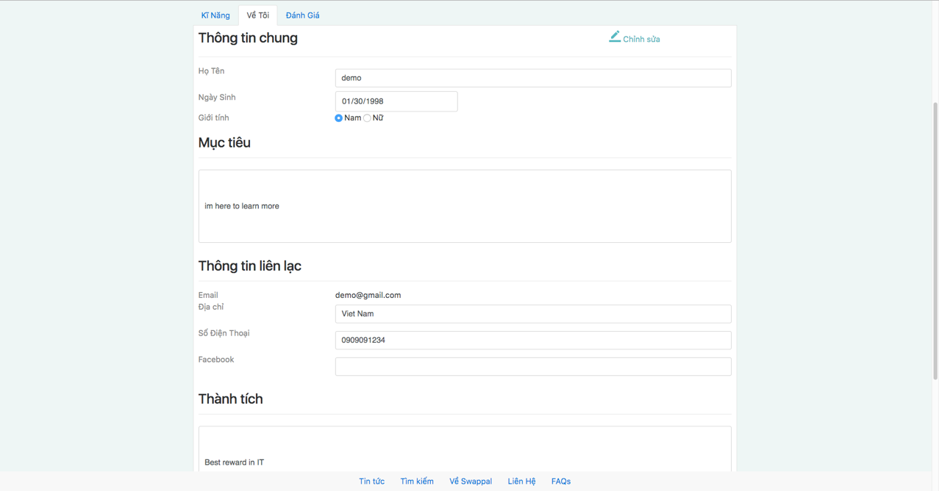

* 1. **Search skills**

User choose skill have and skill need to find out people who match with those skills at home page

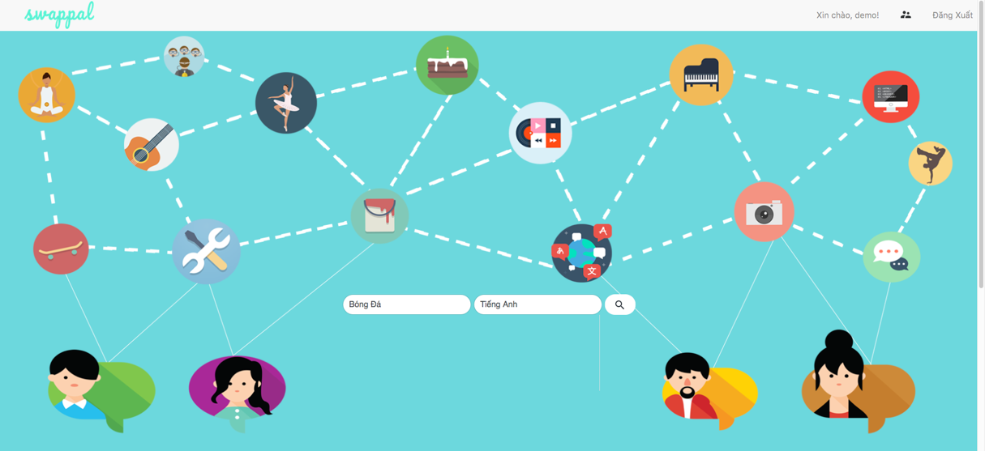

Click on Search icon button to transfer to result list screen

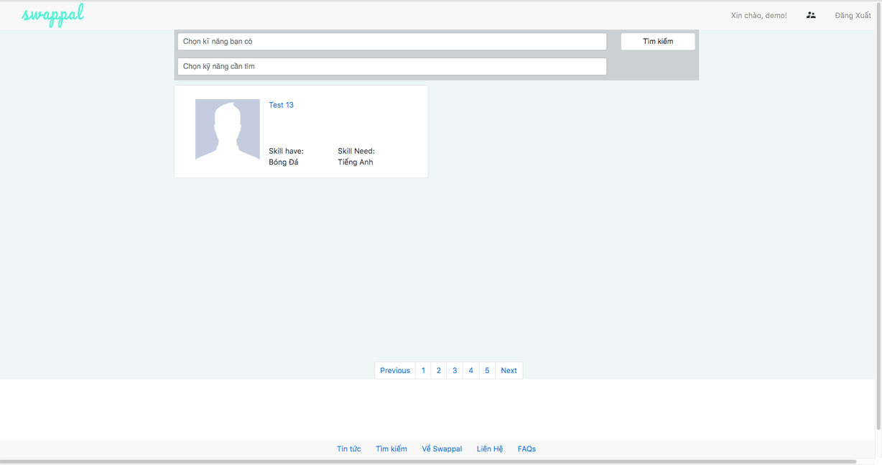

Otherwise, if user does not satisfy with those result, they can choose on “Chọn kỹ năng bạn có” “Chọn kỹ năng bạn cần” to find out skill have and skill need

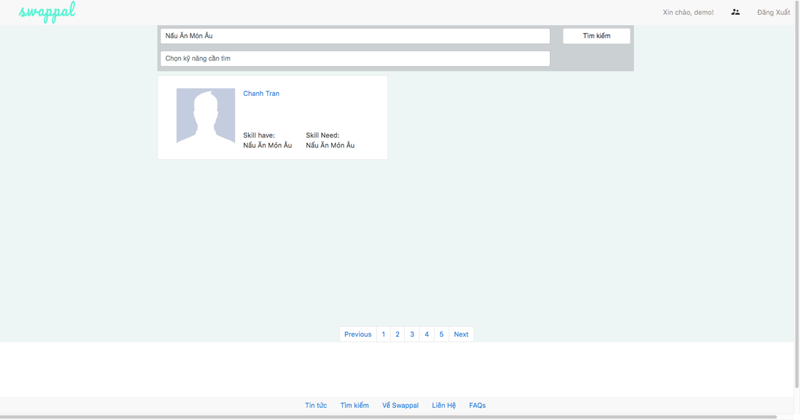

* 1. **View other profile**

After user find out people match those skill, they want to explore more about the user in those skill, user click on other name to display other profile



* 1. **Send request swap**

User feel fit with this person and click on “Trao đổi” button to start a request



User click on done button to send request to other, after request sent, system will display text “Bạn đang gửi yêu cầu” to notice user they just sent request



* 1. **Exchange swap**

When other sent request , user can see the request in history log



Click on each history to open the request , the request include 3 choose ( accept to performance swap , decline the request and reply to negotiate)

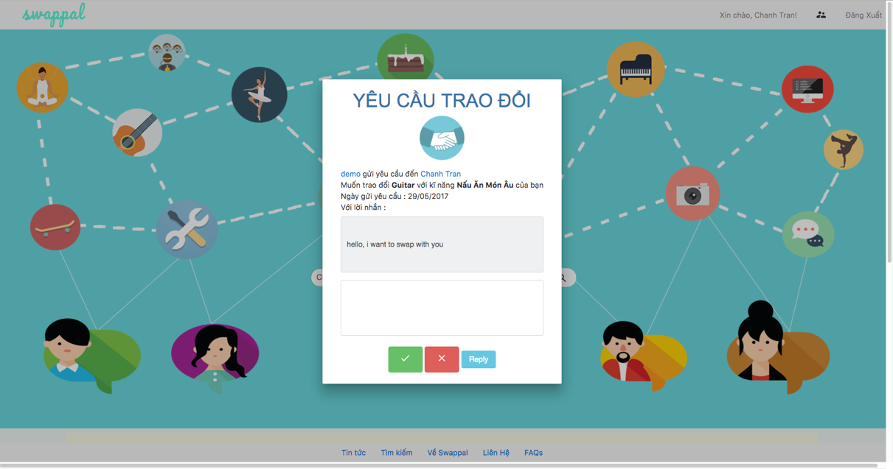

User received message from other and accept the request, system notice they are just accepted the request, wait for other accept one more times.



The request accepted in single side, it need to accepted in couple side, so the system notice to other user have accepted request in history log



User accept one more times to performance the transaction



About the decline, just need single side decline to delete request with notice “Bạn đã từ chối trao đổi”



And other side will see the decline (disabled) in history log



About the reply, user receive request and reply to negotiate, other user will see the message they are replied



* 1. **Write Review**

Write review is allowed when they finish swap process in real life and click on “Hoàn tất trao đổi “ button



Click on “Hoàn tất trao đổi” system will appear Write review dialog for user rating on the skill they swapped , and service of other



User click on “Xác nhận” button to send the review to other

# SWAPPAL CMS